Physical Education Lesson for the Week
May 1st- 31st – National Sport and Fitness Month
May 18th-22nd, 2020

- Check out our Virtual Field Day coming at the end of the month. Flyer Below

- We have covered all the Muscles of the Month for the school year, we are going to continue to do a muscle of the week each week. Review the muscle with your child by saying what the muscle is for the week. Have them show you where it is on their body. Next, show them the picture on the slides to see if they were correct. Finally, explain what it is used for or have them explain what it is used for (attached you can use the slides/pictures to assist with your child).

- Continue Each Day During May to perform the activities on that specific day using your May activity calendar attached.

- Monday-Thursday – Pick a day this week and do a scavenger hunt with your family. At the bottom of the lesson you will see a scavenger hunt list to use. If you don’t like the list provided, you can make up your own scavenger hunt list of 10-12 things before going outside. If you can’t make it in the woods or to a local park for your hike, do a hike around your neighborhood. Attached is a link of one of our Shaler Area Primary PE Department teachers leading the example. Have fun with this and be safe!

Click the Video link https://www.youtube.com/watch?v=CopLrDdEgiM&t=7s

Monday-Thursday – Try to practice your v-sit and reach stretch throughout the week to prepare for the self- test on Friday, working on your Hamstring muscles. See if you can stretch a little bit further than the day before. Do this by practicing during commercials when watching tv or just before you go to bed at night. Work on your flexibility, but remember don’t bounce when stretching you could hurt your muscles. When stretching hold for a few seconds and slowly release.

Friday – Self – Test day- follow the example video provided to help you perform the fitness test for the week involving the Hamstrings. This will be a great way to test your flexibility and hamstring muscles for the week once you have completed all the daily skill/fitness routines.

Self – Test Video = Click the Icon https://www.youtube.com/watch?v=No8wJ3X3A3Y

Try the Following for Friday’s Self-Test Day:
V-sit and reach self-test -Refer to the description at the bottom of the lesson.
Perform V-sit and reach (Hamstring) Self-Test = Fitness Level or Titan Level (refer to charts provided below)

Be Safe, Be Healthy, Stay Active!
Shaler Area School District
Primary PE Department
Yours in Fitness and Health,
Mr. Chmielewski

Muscle of the Week

Muscle of the Week

Function of the Hamstrings
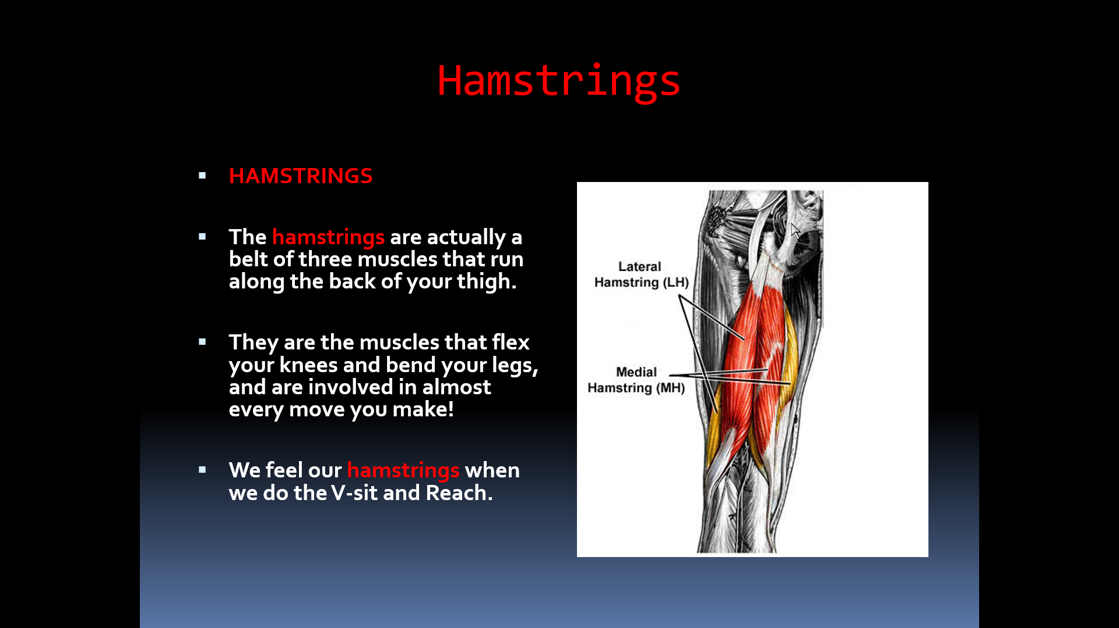

How do we use these muscles in PE?
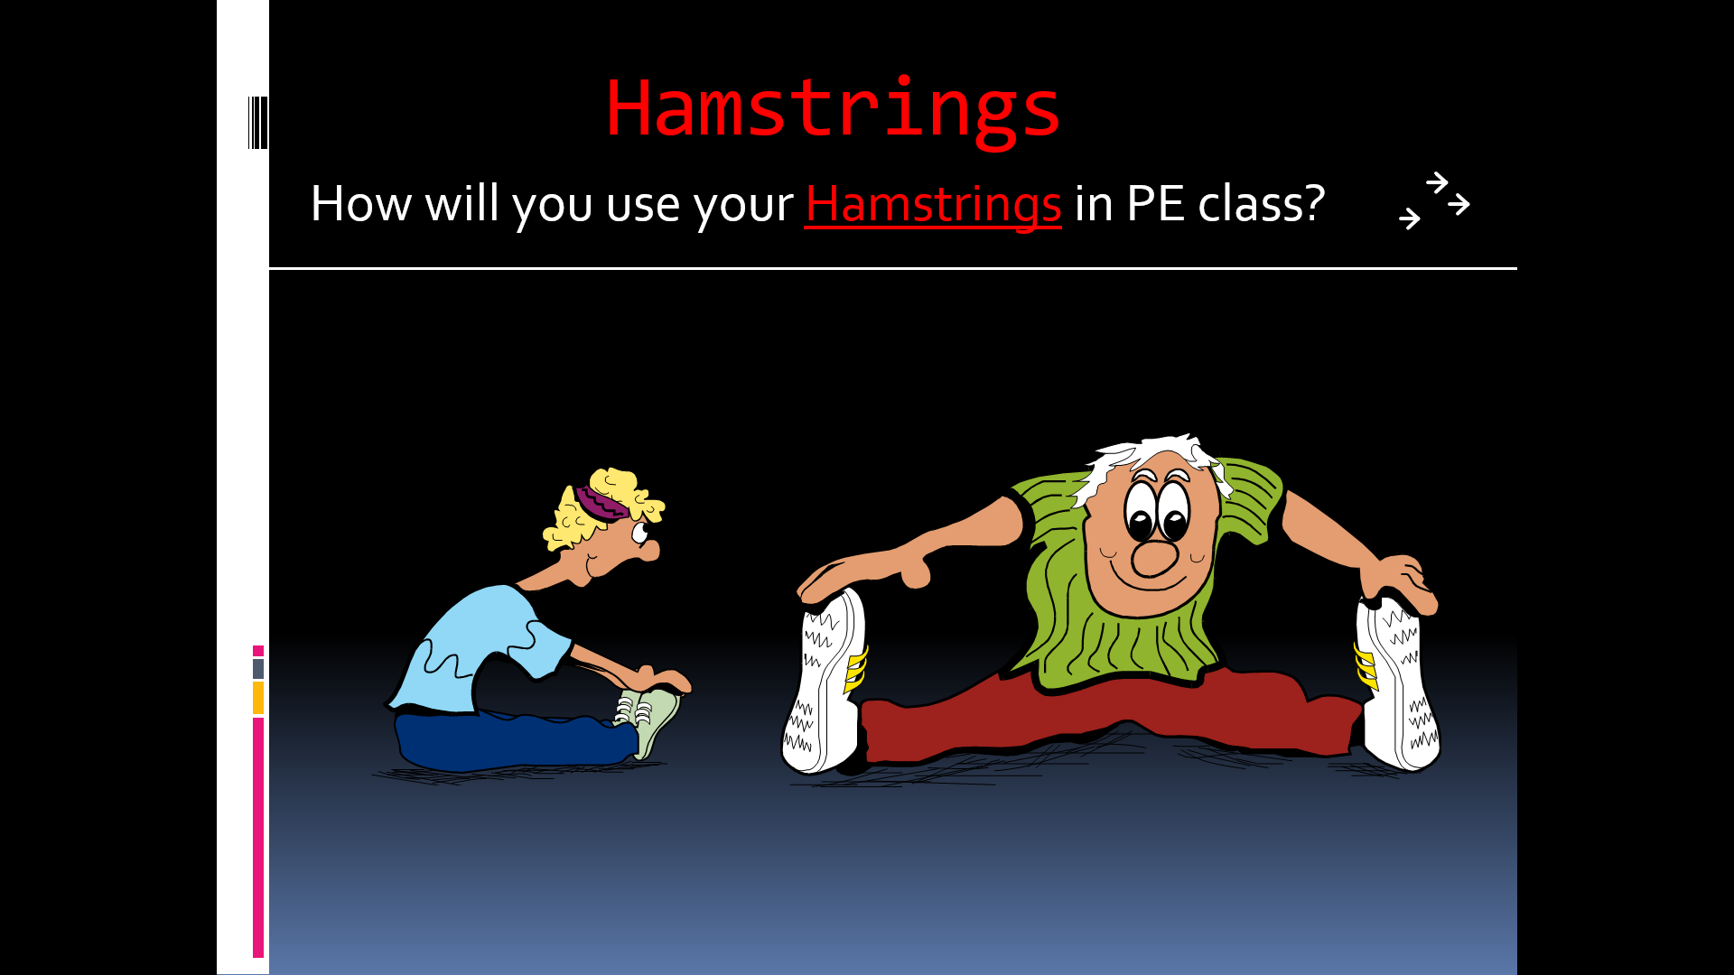
The Fitness Test we use in PE CLASS for the Hamstrings and flexibility is the
V-sit and Reach Test

National Observances  ● May 1-7: National Physical Education and Sport Week ● May 4th: Star Wars Day  ● May 5th: Cinco de Mayo  ● May 6th:National Nurses Day ● May 10th: Mother’s Day |  |  |  |  | 1 Commercial Break  Can you hold a plank for an entire TV commercial break? | 2 Dribble Challenge  Dribble a ball 100 times with each hand. Can you successfully dribble 100 times with each hand while moving?
3 How Fast Can You Go?  Pick a distance and see how fast you can run the distance. | 4 Star Jumps  Jump up with your arms and legs spread out like a star. Do 10 then rest and repeat. | 5 Celebrate  Put your favorite song on and make up a dance or fitness routine! | 6 A Gratitude Attitude Write down something you’re thankful for and why. | 7 Inchworms  Keeping your legs straight place your hands on the ground, walk them into push-up position, and walk your legs up. | 8 Teacup Tip-ups  Place your hands on the ground and gently touch your forehead to the ground balancing your elbows on your knees. | 9 Musical Frogs  This game is just like musical chairs except players hop around like frogs and sit on lily pads (pillows).
10 Positive Talk  Be sure to talk to yourself today like you would talk to someone you love. | 11 Yoga  Yoga is a great way to relieve stress. Try Savasana, considered to be the hardest yoga pose! Fully relax & clear your mind. | 12 Wild Arms  As fast as you can complete: 10 Arm Circles front & back 10 Forward punches  10 Raise the Roof’s Repeat 3x | 13 Mindful Senses  What do you notice around you? Find:  5 things you see 4 things you feel 3 things you hear 2 things smell  1 thing you taste | 14 Crawl Like a Seal  Lie on your stomach, arms straight out front. Use your arms to pull your lower body along keeping your legs and back straight. | 15 Rock Paper Scissors Tag Meet in the middle, shoot, loser chases the winner back to safe zone. If tagged, join the other team.  . | 16 Family Mindful Snacking When eating a snack today, really pay attention to the taste, feel, sound, smell and look of the snack you’re eating. What do you notice?
17 Rock Paper Scissors Tag Meet in the middle, shoot, loser chases the winner back to safe zone. If tagged, join the other team. | 18 Chair Pose  Hold for 30 seconds, relax then repeat. | 19 Paper Plate Planks  In plank position with paper plates under your feet. Complete 30s each:  -mountain climbers -in and out feet  -knees to chest | 20 Commercial Break  Can you hold a plank for an entire TV commercial break? | 21 Jump, Jump  Jump side-to-side over an object or line for 1 minute straight. Go again but jump front to back. Repeat each jump twice. | 22 Positive Talk  Be sure to talk to yourself today like you would talk to someone you love. | 23 Play Catch  Grab any kind of ball and play catch with a family member. Keep your eyes on the ball and catch it with your hands not your body.
24 Before Bed Breathing  While lying in bed, place your hands on your stomach and pay attention to the up and down of your belly as you breathe. | 25 Crane Pose  Here’s a challenge! Put your hands on the ground, lean forward & balance your knees on your elbows. | 26 Step Jumps  Find a step or a bench and jump up and down 50 times. Be careful. Take a break if you need to. | 27 A Gratitude Attitude Write down something you’re thankful for and why. | 28 Wake and Shake  As soon as you get out of bed shake your body any way you like for 10 seconds. Are you up now? Good! Now jump up and down 10 times. | 29 Walls  Face each wall in a room and do a different exercise for 30 seconds  -side shuffle  -grapevine to left then right -wide stance punches  -vertical jumps | 30 How Fast Can You Go? Pick a distance and see how fast you can run the distance.
31 Wild Arms  As fast as you can complete: 10 Arm Circles front & back 10 Forward punches  10 Raise the Roof’s Repeat 3x | SHAPE America recommends school-age children accumulate at least 60 minutes and up to several hours of physical activity per day. Each bout of physical activity should be followed by cool-down stretches that help reduce soreness and avoid injury. Happy exercising!  Reproduced with permission from the Society of Health and Physical Educators (SHAPE America) https://www.shapeamerica.org/publications/resources/teachingtools/teachertoolbox/activity-calendars.aspx

NATURE HIKE SCAVENGER HUNT WORKSHEET
Find as many of the items below as you can in 5 minutes or just try to find as many items as you can before you leave the woods. Cross off any of the items you see when you are on your Hike. You can use this list or make your own. HAVE FUN! Score 1 point for each one your team collects!
Leaf Rock Pinecone Weed or Flower Stick
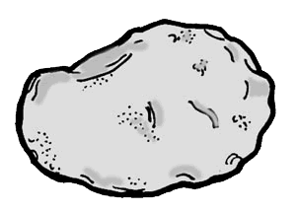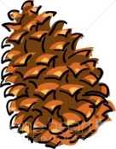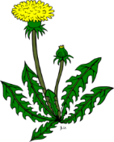

Acron Fallen Tree Squirrel Plants Chipmunk
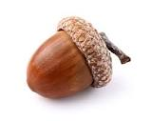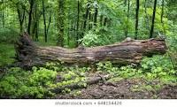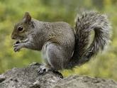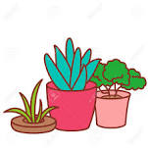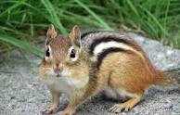
Trash or something
You do not see in the
Bird Creek woods Poison Ivy Gopher Hole
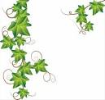

Deer Tracks Tree Stand Deer Trail Deer Sun
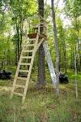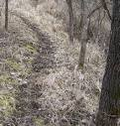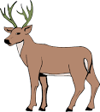
V-sit and reach Description:
With your shoes off place your feet 8 to 12 inches apart on line marked on the floor. This is the baseline which will be crossed by a measuring line that will be used to measure flexibility. Clasp your thumbs so your hands are together with palms facing down, then place them on the measuring line. Keep your legs straight and keep your toes facing upward. As you reach forward exhale and reach as far as you can. Students who reach past their feet will receive a “+” number, students who reach before their feet receive a “-“number, and any student who reach to their feet is recorded as a “0”.

V-SIT REACH

(inches)
AGE | BOYS  ~  FITNESS | BOYS  ~  TITAN | GIRLS  ~  FITNESS | GIRLS  ~  TITAN
6 | +1 | +3½ | +2½ | +5½
7 | +1 | +3½ | +2 | +5
8 | +½ | +3 | +2 | +4½
9 | +1 | +3 | +2 | +5½
10 | +1 | +4 | +3 | +6

Coming
The week of May 25th!

